Applying the
Engineering
Design Process
Building Bridges

NAME: ___________________________ _________________________________
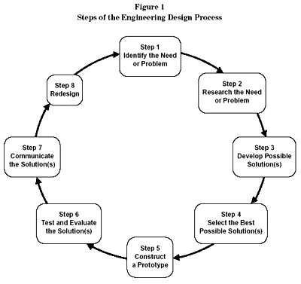

STEP 1: identify the need or problem

You need to design and construct a bridge using only materials supplied by the Rice Lumber Company which meets the “Bridge Building Code” criteria and rules. Your finished 3-D model of the bridge should match your drawn 2-D plans in all views of the bridge.

STEP 2: research the need or problem

Please write down at least 5 questions you have about this project. Make sure to leave space to write answers to each of your questions during a question and answer period. (Make sure to number each of your questions) (2 pts ea question/answer)

STEP 3: develop possible solutions (brainstorm)

On the graph paper found in this packet, you must draw your idea for a bridge. Your drawing must include four (4) views of your bridge: a top view, a side view, an end view and a deck view. You must label each of these views with the underlined words above. (When constructing your bridge, both sides will follow the same plan and both ends will follow the same plan.) (2 pts each view drawn and labeled)

Before bringing your idea to your group, you will have an opportunity to “play” with toothpicks while looking at your possible solution (your design idea for different views). As you “build” a view according to your drawing, you must write down and circle approximately how many toothpicks this part of the bridge will take to construct if your idea is selected. (This number should be written and circled on the graph paper drawing of your idea for a bridge.) This will be important information to bring to your group discussion. (1 pt ea view has an approximate number of toothpicks and number is circled)

STEP 4: select the best possible solution

Once bridge groups have been set, all members of the group will bring individual ideas (your drawing and approximate number of toothpicks each view will take to construct) to a group planning session. As a group, you will look at all ideas and come up with one plan for each of the views listed above. Building cannot begin until your group has submitted final plans to Mrs. Rice.

What do you think will be the most challenging part of this group project? WHY? (explain using detail and complete sentences) (2 pts)

What do you think will be the least challenging part of this group project? WHY? (explain using detail and complete sentences) (2 pts)

STEP 5: construct a prototype

Draw your finished bridge below. This should be a side view of your bridge
Using a ruler, you must also measure (in cm) the different parts of your bridge on your ACTUAL BUILT BRIDGE. Then in your drawing below, list the measurements (you need at least 3 different measurements listed). (you are measuring your actual bridge and recording these measurements on your picture; however your picture does NOT need to be drawn to these measurements) (6 pts)

Did you build any of the views (top, deck, end or side) that your group drew on your final plans exactly the way that they were drawn? If yes, which view(s)? (1 pt)

_______________________________________________________________________

Which view was the easiest to build? Why? (2 pts)______________________________

_______________________________________________________________________

Which view was the hardest to build? Why? (2 pts)______________________________

_______________________________________________________________________

What is the dead load of your bridge? (don’t forget your label) __________________ (1 pt)

Make a hypothesis…
What do you think will be the live load that your bridge will be able to hold? (your hypothesis should be made in pounds as this is how it will be measured)

(don’t forget your label) _________________________ (1 pt)
What is this equivalent to in grams? (multiply pounds by 454 … label) ____________________ (1 pt)

STEP 6: test and evaluate the solution(s)

BRIDGE BREAKING DAY ---

What was the actual live load your bridge held? In grams ___________ (1 pt)
In pounds ___________ (1 pt)

What was the difference between your hypothesis and the actual live load in pounds --- were you over or under and by how much? _________________________ (1 pt)

How efficient was your bridge? (how many times its own weight did it hold?) __________ (1 pt)

STEP 7: communicate the solution(s)

What part of your bridge do you think was the weakest? WHY do you think this part was the weakest? Did you do something different when you were building this part? (explain using detail and complete sentences) (2 pts)

What part of your bridge do you think was the strongest? WHY do you think this part was the strongest? Did you do something different when you were building this part? (explain using detail and complete sentences) (2 pts)

STEP 8: redesign

If you could build another bridge using the same materials and criteria, what would you change or do differently to improve your bridge? HOW would this change improve your bridge? (explain using detail and complete sentences) (2 pts)

If you could build another bridge and could add a building material, what building material would you add and how/where in your bridge would you use this material? How much would you charge for this material? (must be an easily accessible household/classroom material and cannot be steel, concrete, etc.) (3 pts)

If you could add or change a criteria or rule having to do with this project, what rule/criteria would you change or add and HOW would this affect your bridge or building? (2 pts)

